Experiment No. 5
Title:
Implementation of Stack Using Array in C.
Aim:
To implement a stack data structure using an array in the C programming language, supporting the basic stack operations: push, pop, peek, and display.
Requisites:
Hardware: A computer with minimum 2GB RAM
Compiler (like GCC)
Software: Text editor (Code::Blocks, VS Code, or Notepad++)
C compiler (GCC or Turbo C)
Description:
This experiment focuses on the implementation of a stack data structure using an array in the C programming language. A stack is a linear data structure that follows the LIFO (Last In, First Out) principle. The element inserted last is the first to be removed.
In this program, a fixed-size array is used to hold stack elements, and an integer variable top is used to keep track of the current top position in the stack.
The stack supports the following operations:
Push: Inserts an element at the top of the stack.
Pop: Removes the top element from the stack.
Peek: Retrieves the top element without removing it.
Display: Shows all elements of the stack from top to bottom.
Proper checks for stack overflow (when pushing into a full stack) and stack underflow (when popping from an empty stack) are implemented to prevent runtime errors.
The program provides a menu-driven interface to allow the user to interactively perform stack operations.
This implementation demonstrates how a stack can be realized using static memory allocation (arrays) and helps reinforce the concept of stack operations and error handling in C programming.

Algorithm:
1. PUSH Operation
Push(element):
if top == MAX - 1:
print "Stack Overflow"
else:
top = top + 1
stack[top] = element

2. POP Operation
Pop():
if top == -1:
print "Stack Underflow"
else:
element = stack[top]
top = top - 1
return element

3. PEEK Operation
Peek():
if top == -1:
print "Stack is empty"
else:
return stack[top]

4. DISPLAY Operation
Display():
if top == -1:
print "Stack is empty"
else:
for i = top to 0:
print stack[i]

Conclusion:
In this experiment, we successfully implemented a stack data structure using an array in C. We covered fundamental operations such as push, pop, peek, and display. The implementation demonstrated the LIFO (Last-In-First-Out) behavior of stacks and included checks for stack overflow and underflow conditions.

C Program Code:
#include <stdio.h>
#include <stdlib.h>

#define MAX 100 // Maximum size of stack

int stack[MAX]; // Array to store stack elements
int top = -1; // Variable to keep track of the top element index (-1 means stack is empty)

// Function to push element onto stack
void push(int value) {
if (top == MAX - 1) { // Check if stack is full
printf("Stack Overflow! Cannot push %d\n", value);
} else {
top++; // Increment top index
stack[top] = value; // Insert the value at top
printf("Pushed %d to stack.\n", value);
}
}

// Function to pop element from stack
void pop() {
if (top == -1) { // Check if stack is empty
printf("Stack Underflow! Cannot pop.\n");
} else {
printf("Popped %d from stack.\n", stack[top]);
top--; // Decrement top index
}
}

// Function to return the top element without removing it
void peek() {
if (top == -1) { // Check if stack is empty
printf("Stack is Empty.\n");
} else {
printf("Top element is %d\n", stack[top]);
}
}

// Function to display all stack elements
void display() {
int i;
if (top == -1) { // Check if stack is empty
printf("Stack is Empty.\n");
} else {
printf("Stack elements (top to bottom):\n");
for (i = top; i >= 0; i--) { // Print from top to bottom
printf("%d\n", stack[i]);
}
}
}

// Main function with menu-driven program
int main() {
int choice, value;

while (1) { // Infinite loop until user chooses to exit
printf("\n--- Stack Menu ---\n");
printf("1. Push\n2. Pop\n3. Peek\n4. Display\n5. Exit\n");
printf("Enter your choice: ");
scanf("%d", &choice);

switch (choice) {
case 1:
printf("Enter value to push: ");
scanf("%d", &value);
push(value); // Call push function
break;
case 2:
pop(); // Call pop function
break;
case 3:
peek(); // Call peek function
break;
case 4:
display(); // Call display function
break;
case 5:
exit(0); // Exit the program
default:
printf("Invalid choice! Try again.\n");
}
}

return 0;
}

OutPut:
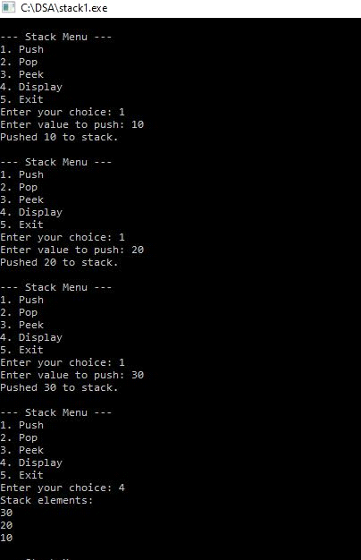
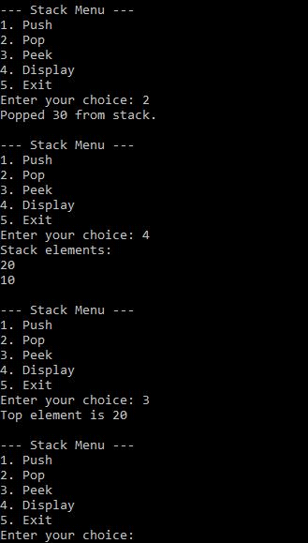

Viva Questions
- What is a stack and what principle does it follow?
- What is the LIFO (Last In, First Out) principle?
- What are the basic operations performed on a stack?
- What is the purpose of the top variable?
- Why is top initialized to -1?
- What is stack overflow and when does it occur?
- What is stack underflow and when does it occur?
- What is the difference between pop() and peek() operations?
- What is the time complexity of push and pop operations?
- What are the real-life applications of a stack?

Practical Applications of Stack in Real Life
Stacks are widely used in computer science and real-world applications. Some important applications are:
- Undo/Redo Operations
Applications such as MS Word, Photoshop, and text editors use stacks to store previous actions so that users can undo or redo operations.
- Browser Back Button
Web browsers can use a stack to keep track of previously visited web pages. The most recently visited page is accessed first when the Back button is pressed.
- Function Calls and Recursion
Programming languages use a call stack to store information about function calls, local variables, and return addresses.
- Expression Evaluation
Stacks are used to evaluate arithmetic expressions such as:
  - Infix expressions
  - Postfix expressions
  - Prefix expressions
- Parentheses Matching
Compilers and programs use stacks to check whether brackets such as (), {}, and [] are properly balanced.
- Backtracking
Stacks are useful in problems such as maze solving, depth-first search (DFS), and other backtracking algorithms.
- Memory Management
The runtime stack is used by programs to manage function calls and local variables during program execution.
- Navigation Systems
Stack-based techniques can be used to keep track of navigation history and return to previously visited states.

Recommended Modifications for Students
For better understanding, students can implement the modifications in this order:
Basic → Intermediate → Advanced
- Basic: isEmpty(), isFull(), size(), clearStack()
- Intermediate: Search, graphical display, input validation
- Advanced: Stack using structure, linked list implementation, expression evaluation
This progression helps students understand the concept of stack first, then program organization, and finally real-world applications.

